**It is recommended that Visual Studio 2019 be loaded on your own PC** (see below)**.**

**Only on a Seneca lab PC** can youlaunch **MS Visual Studio 2019** from[**myApps**](http://inside.senecacollege.ca/its/software/myapps/)**.**

Visual Studio is a “fully-featured, extensible, free IDE for creating modern applications for Android, iOS, Windows, as well as web applications and cloud services.”

|  |  |  |
| --- | --- | --- |
|  | **hover cursor and launch 🡺** |  |

*Troubleshooting myApps*: first be patient, the app…is…being…downloaded…from the cloud. After running out of patience, try reloading the page. If your UserID will not validate or the Visual Studio item itself needs validation, visit the ITS Service Desk in the Learning Commons: there may be a problem with your user account's permissions. Although [myApps](https://myapps.senecacollege.ca/login) is available remotely, only applications without licensing constraints, e.g. Open Source, can be launched from other than a Seneca PC.

*On your own computer*, please install Visual Studio Community IDE from <https://www.visualstudio.com/vs/community/>. During VS Installation, select the Workload "Desktop development with C++".

Visual Studio IDE **runs only in a Windows environment**. *Apple macOS users and Linux gurus* must run a dual boot system (e.g. Apple [Bootcamp](https://support.apple.com/en-ca/boot-camp)) or run the VS IDE inside a virtual machine (e.g. [Parallels](http://inside.senecacollege.ca/its/software/hub/senecahup.html) for macOS). *Installing Visual Studio for macOS will just waste your time.* [*Visual Studio Code*](https://code.visualstudio.com/docs/languages/cpp) *as a native macOS alternative for C/C++ programming has made progress but is still in* Preview*.* [*YMMV*](https://www.urbandictionary.com/define.php?term=ymmv)*.* The IPC144 course lectures, workshops, and how-to instructions assume the use of Visual Studio IDE.

Students are licensed to use Windows 10 OS and other software; go to <SICT.CA>, Students / Current Students, hover over **Resources for Students**, click on **Microsoft software for School of ICT students** and follow the notes there for your CPD / CPA / BSD program. While you are there, look into this term's **Enrollment FAQ** and the **New Student Guide**.

***To start Visual Studio IDE*:**Press the Windows key or click the Windows icon in the lower left and start typing “Visual Studio” until you see   
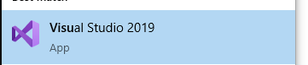 (click on this or press Enter to launch)

**Show these notes on one side of your screen: Windows key + 🡪 [right arrow]**

**Show Visual Studio beside these notes with Windows key + 🡨 [left arrow]**

Because Visual Studio (VS) can manage various types of projects, it is one of the industry standards for systems development. As such, it is far more than just a programming code editor. Thus, the next few steps require your careful attention to set up the VS project for the type of program we will be creating.

From the **Visual Studio 2019**, **Get started window …**

**Create a new** [**project in Visual Studio**](https://msdn.microsoft.com/en-us/library/b142f8e7.aspx)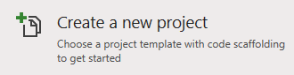

**Or, click on**  **to get to the application menu**

* + use VS menu: select File | New | Project (Ctrl+Shift+N)  
    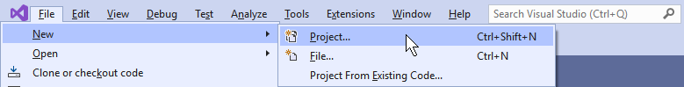
* On the **Create a new project** display, select **Empty Project** and press Enter  
  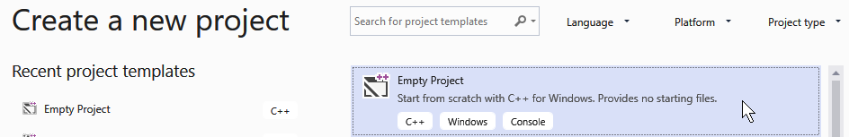
* Enter **CP4P**_**W1** as the Project Name   
  (**C**omputer **P**rinciples ***for*** **P**rogrammers _ Week 1)
  + Note the Location (or override it) before continuing by clicking Create in the bottom right corner  
     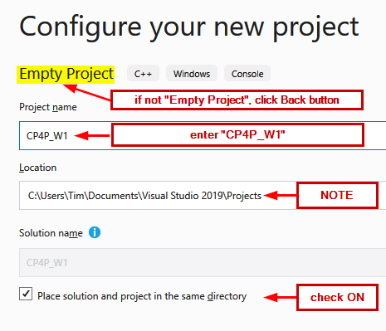

**Create a C language source code file…**

* VS menu: select Project | Add new Item (Ctrl+Shift+A)  
  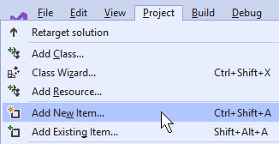
* Check that Visual C++ is selected on the left   
  and **C++ File (.cpp)** in the center pane is also selected  
  enter [**helloWorld.c**](https://en.wikipedia.org/wiki/%22Hello,_World!%22_program) as the file Name | press Add
  + ***Make sure the file extension is “.c”, not the default .cpp  
    This forces Visual Studio to use the C compiler instead of C++***

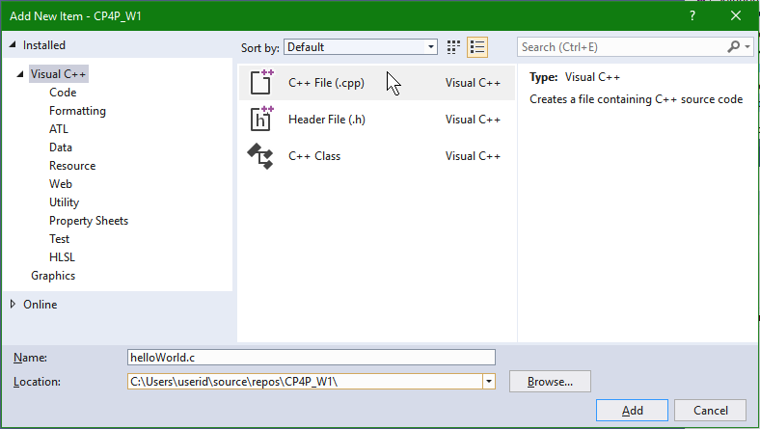

* Copy & paste the source code for the classic first program, “Hello World”.  
  Change yourNameHere to your own name.

/* Thanks to Brian Kernighan, 'Hello World' is the traditional first C program. It became legendary with the publication of "The C Programming Language" by Kernighan and Ritchie (1978). Now, Hello World is the canonical test of any programming language. */

#include <stdio.h> // C language module providing Input/Output facilities

int main(void) // main() is always called to start a C program

{

printf("Hello, World!\n"); // output greeting

printf("This is yourNameHere.\n"); // output your name

return 0; // return to operating system

}

*See* [*Hello World*](https://en.wikipedia.org/wiki/%22Hello,_World!%22_program)*,* [*The History of ‘Hello, World'*](https://blog.hackerrank.com/the-history-of-hello-world/)*,* [*The Hello World Collection*](http://helloworldcollection.de/)

* If the first line of comments is not wrapping,
  + VS menu: Edit | Advanced | Word Wrap (Ctrl+EW)
* Save the source file (Ctrl+S)

Compile your C program…

* VS menu: select **Build** | **Build Solution** ( F7 or Ctrl+Shift+B )

The Output pane below your code should show Build: 1 succeeded  
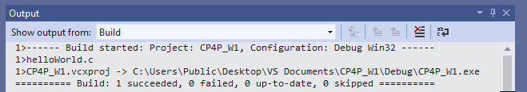

**If it did not succeed** and your source code exactly matches the above,   
look at the Solution Explorer pane (Ctrl+Alt+L to View it)   
 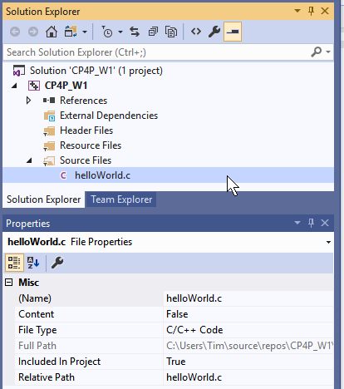

* Only one source file should exist in the project
  + delete all except **helloWorld.c**
* Check that **helloWorld** ends with the extension **.c** and not **.cpp**
  + Use the Solution Explorer / Properties pane to rename the file to end in **.c**
* …and run Build Solution again.
* If all else fails, it is best to start again.
  + Exit Visual Studio
  + Use File Explorer to find the CP4P_W1 folder under …\repos\
  + Delete the CP4P_W1 folder
  + Then recreate the project as per the above notes.

**When the compile was successful,** run your program.

* VS menu: select **Debug | Start without Debugging** (Ctrl+F5)
* a terminal console window will open with   
  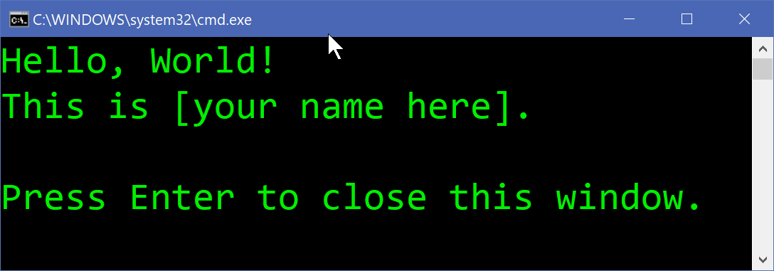  
  The appearance of the window varies.   
  Customize by clicking the icon in the top left / Properties.
* Close the window when you’ve sufficiently admired your work.

**Now, where is that** helloWorld.c **source file?**   
You may have seen the full pathname when your program ran in the terminal window.  
Source files are located under the VS Project name folder. And where is that?  
There are a number of ways to find it.

You can start from the file’s location and work your way up the folder structure:

* Press the Windows key and type the filename **helloWorld.c**
* Right clicking on the filename, depending on your PC’s configuration, may give you a list of options such as Open file location, Copy full path

You can use Visual Studio:

* Hover the mouse pointer over the **helloWorld.c** tab in the editing pane and the full path will appear.
* Right click on the **helloWorld.c** tab in the editing pane for more options.
* In the Solution Explorer pane, right click on the project name and select Open Folder in File Explorer and search from there.

You can use the Windows File Explorer ( + E)

* File Explorer has a Search feature but if you search “This PC” for **file:helloWorld.c**, your patience will be tested. Before searching…
* Use the left pane to navigate to Windows (C:) and click on the Users folder
  + Then search for the helloWorld.c file

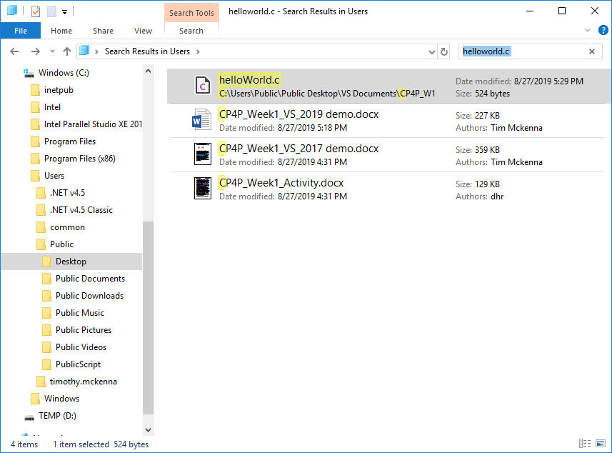  
  
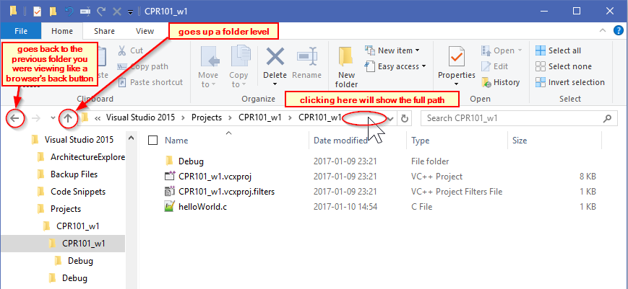

Test your Solution on the Remote Host (Matrix)

matrix.senecacollege.ca is a Linux [cluster](https://en.wikipedia.org/wiki/Computer_cluster) which is the host server for your completed C programs. First, upload your C source code file to matrix via an FTP application (File Transfer Protocol).

Go back to myApps. Find and launch **WinSCP**. Or, download and install an FTP Open Source app such as WinSCP or Filezilla on your own machine. Also, most operating systems have command line FTP built in. (You can launch <https://myapps.senecacollege.ca/> from your own computer however only applications that have no licensing constraints, e.g. Open Source, can be launched from other than a Seneca PC through AppsAnywhere. Thus, myApps is useful only on a lab PC.)

Input your Seneca credentials: UserID and Password on either the WinSCP dialog or leave blank there and input directly on matrix.  
**N.B.** **ensure you input your UserID in lower case**. Unix regards 'a' and 'A' as different characters in UserIDs, directory/file names, and on the command line unlike most other OSs which are case independent in those instances. Passwords are *always* case sensitive in any contemporary OS.

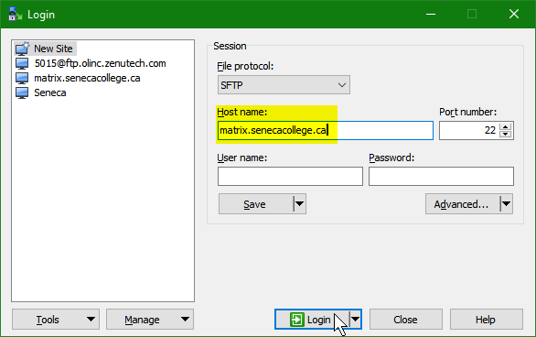  
  
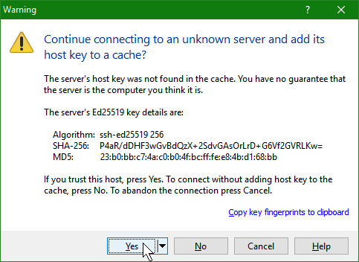

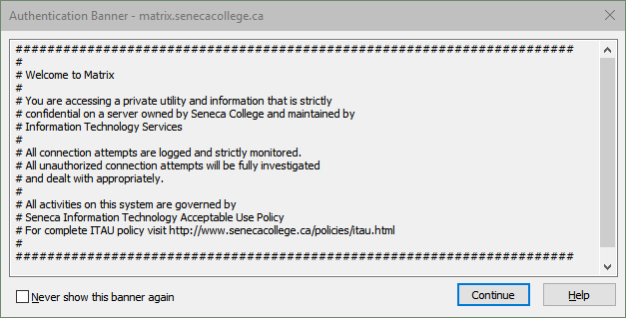

In the right hand panel, click New, then Directory,   
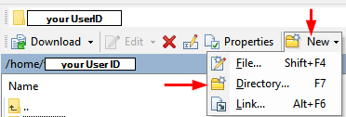

Enter a directory/folder name, e.g. W01 (for "Week 1")  
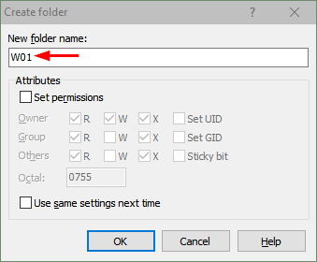  
  
Double click your new directory/folder name to make it your current directory/folder  


Find your helloWorld.c source file using the left panel, click on your source file and drag/drop it to the right panel. This will transfer your source file from your local computer to the directory named W01 on the matrix server.  
*Make sure the files are transferred in text and not binary, change the transmission setting from automatic to text.*

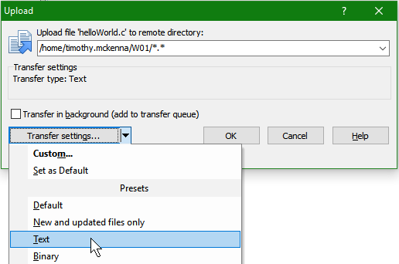

Double click on the file in the right hand panel to see the file's contents. Close that window.

Compile and run your program on matrix using a traditional terminal and command line interface

Go back to myApps. Find and launch **Putty**. "PuTTY is the name of a popular SSH and Telnet client. Any other meaning is in the eye of the beholder. It's been rumoured that ‘PuTTY’ is the antonym of ‘getty’, or that it's the stuff that makes your Windows useful, or that it's a kind of plutonium **T**ele**TY**pe. We couldn't possibly comment on such allegations." [URL](https://www.chiark.greenend.org.uk/~sgtatham/putty/faq.html#faq-meaning)

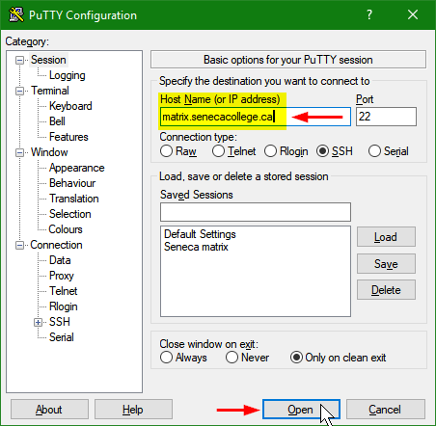

login as: **yourUserID**

######################################################################

#

# Welcome to Matrix

#

*<snip>*

#

# All activities on this system are governed by

# Seneca Information Technology Acceptable Use Policy

# For complete ITAU policy visit http://www.senecacollege.ca/policies/itau.html

#

######################################################################

yourUserID@matrix.senecacollege.ca's password: **yourPassword**

Last login: Thu Sep 13 17:42:46 2018 from 174.93.86.94

[yourUserID@mtrx-node02pd ~]$ **cd W01** *change to the directory containing your source file*

[yourUserID@mtrx-node02pd W01]$ **ls** *list the current directory–is your source file there?*

helloWorld.c

[yourUserID@mtrx-node02pd W01]$ **gcc helloWorld.c -o helloWorld** *compile your source file*

[yourUserID@mtrx-node02pd W01]$ **helloWorld** *run your program*

Hello, World!

This is *yourNameHere*.

[yourUserID@mtrx-node02pd W01]$ **logout** *sign off*